36.16: The total intensity is given by drawing an arc of a circle that has length 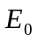 and finding the length of the cord which connects the starting and ending points of the curve. So graphically we can find the electric field at a point by examining the geometry as shown below for three cases.
a) 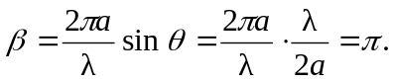 From the diagram, 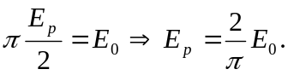
So the intensity is just: 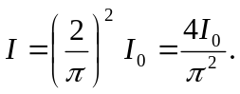
This agrees with Eq. (36.5).

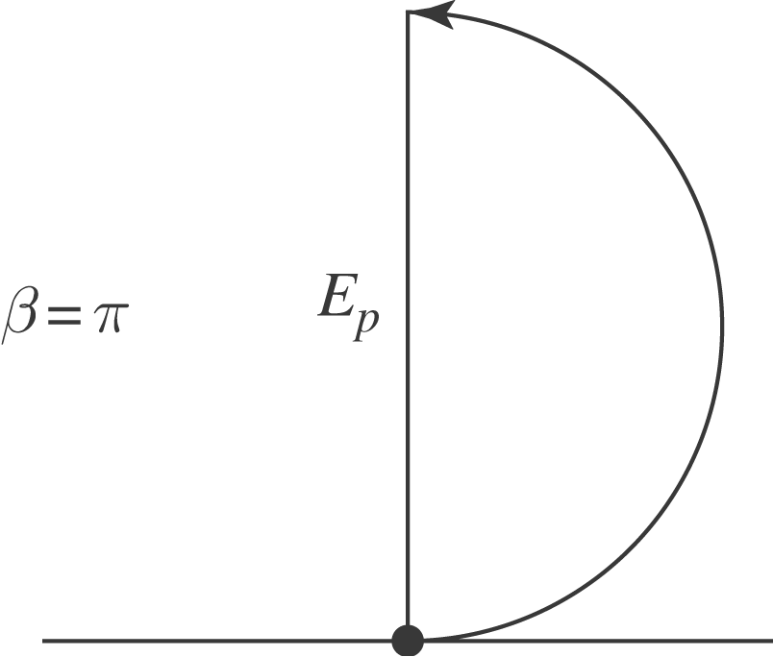
b)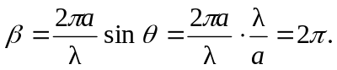 From the diagram, it is clear that the total amplitude is zero, as is the intensity. This also agrees with Eq. (36.5).

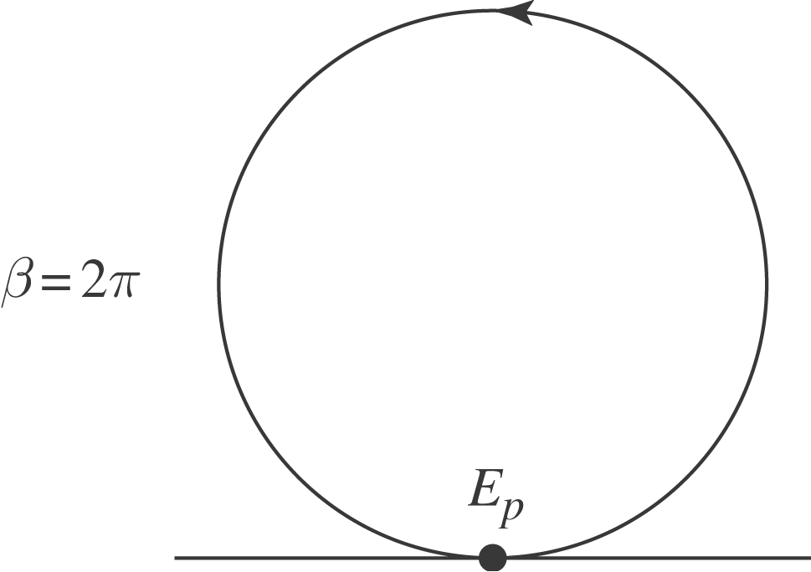
c) 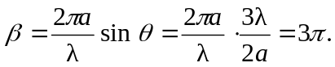 From the diagram,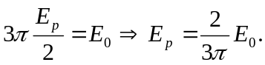 So the intensity is just:
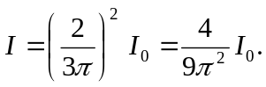
This agrees with Eq. (36.5).

